**FANIMATION**

|  |  |  |
| --- | --- | --- |
| **Supervisor:** | Sir.Salman. | |
| **Batch:** | 2206f. | |
| **Group:** | Fanimation. | |
| **Serial No.** | **Enrollment No.** | **Student Name.** |
| 1. | 1395115 | Ashwyn. |
| 2. | 1395101 | Mark. |
| 3. | 1387493 | Ubaidullah. |
| 4. | 1386763 | Ayesha. |

***Acknowledgement***

The first, we would like to express my special thanks of gratitude to my teacher **Sir Salman** who helped a lot in finalizing this project within the limited time frame, valuable counseling and assistance for the accomplishment of this project.

Secondly, we would also like to thanks the e-project team at Aptech Head Office, who gave as the opportunity to do this interesting and wonderful project about **Fanimation**.

Thirdly, we also thank the e-project team for giving this task to us. Following are the benefits of this Project:

* Re-enforcement of skills happens in the experimental learning process.
* A mentor, ensuring that we do not get drifted, constantly guide us.
* It gives us a lot of confidence to face an interview as we have worked on a project. We can explain virtually everything on the subject we have learnt.

***Synopsis***

**Fanimation** is in the business of revolutionizing home appliances, by solving one problem at a time. Every household appliance we create blends mindful design, energy-efficiency and next-gen smart tech. We think, dream and obsess over customer experience. We are **Fanimation**.

**Fanimation** is a global manufacturer of standard and custom fans and fan accessories. With over 40 years of experience, **Fanimation** has been supplying quality engineered cooling products and assemblies to a wide range of industries and applications. **Fanimation** has engineering, sales and manufacturing facilities **Fanimation** strives hard to be environmentally friendly. We encourage you to browse our products online, which includes all the latest information on our great products and styles.

**Fanimation** is an online store to assist people making purchases online. The synopsis of **Fanimation** is to develop a general-purpose e-commerce store where any type of fan (such as ceiling fans, pedestal fans, wall fans, exhaust fans etc.) can be bought from the comfort of home.

***Problems Definition***

Mr. “X” is the owner of a big outlet of Fans. He is famous for the customer’s satisfaction and quality of the product they provide.

As the number of customers is increasing day by day, the branches of the shop keep on increasing. To expand the business more, the owner of the company has decided to go for making the website of his shop. For this he has approached you to make the website. He wants to facilitate his registered customer by offering them the option of home delivery so they can purchase any type of fan they want while sitting on their couch under a reasonable delivery fair.

Those customers who had registered in the website would be able to make a purchase. For unregistered users a login page would be available to register themselves to the website.

He provides warranty of a minimum of 1 year over every product. He also wants the user to provide their feedbacks or any kind of complaint regarding their website experience and product.

***Customer Requirement Specification (CRS)***

The Website is created based on the following requirements:

1) The Top of the Page is presented with a suitable logo and images of

Ceiling fans, Pedestal fans.

2) The website contains various sections viz. Ceiling fans, Pedestal fans, Wall fans, Exhaust fans, Accessories with products listed in these categories.

3) Menu should be provided with the section names and should be linked to the

sections.

4) Filters should be provided for Category, Type, Price Range, Color, Brands etc.

5) Gallery is available with different images.

6) Product Review and Rating is allowed to enter by the user.

7) About Us: This menu option displays Name, Email id and Contact number.

8) Color combination is uniform throughout the project.

9) Navigation is smooth.

10) The site displays a visitor count at the top right corner of the page beside the navbar.

11) The menu option changes color on hover and also after clicking.

***Sitemap***

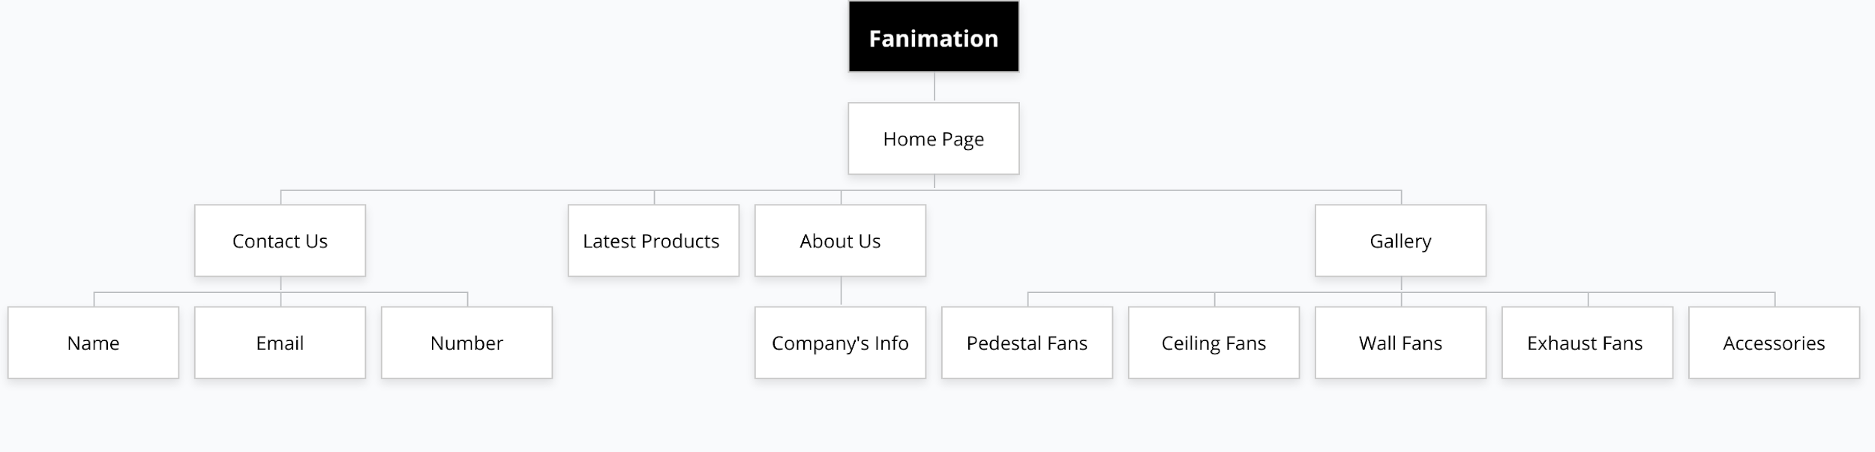

***Wireframes***

***Home page***



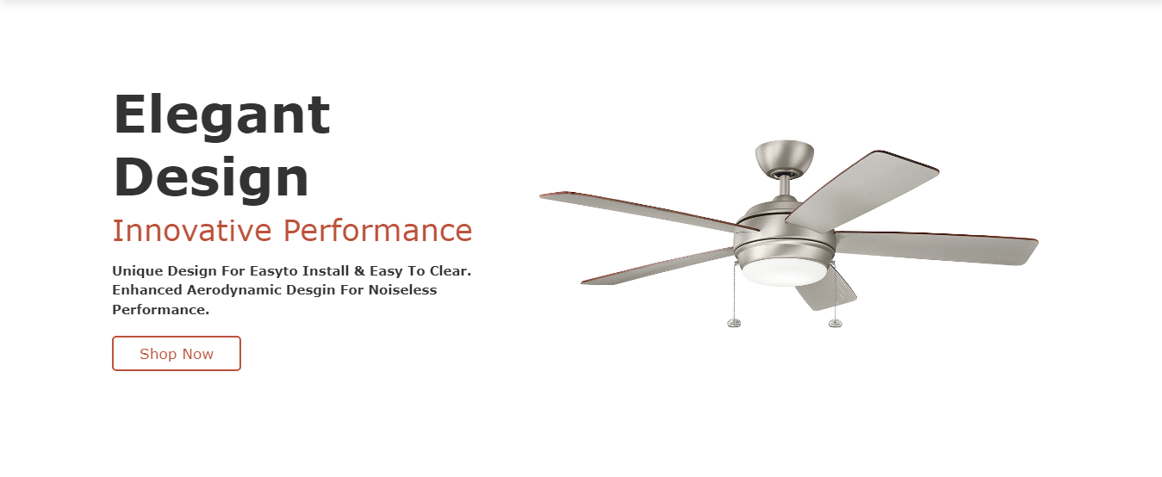

***Contact Us***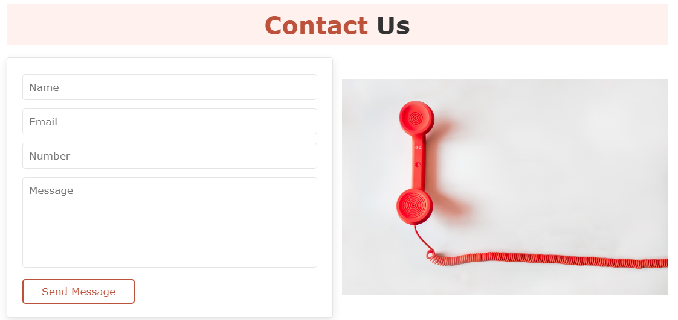

**About Us**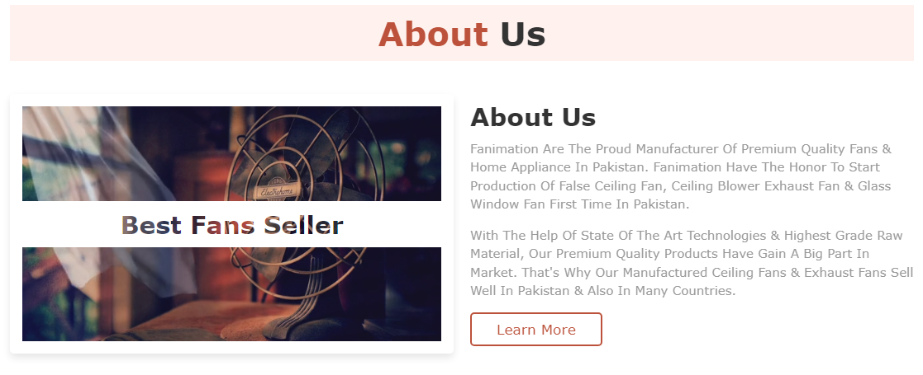

**Gallery**

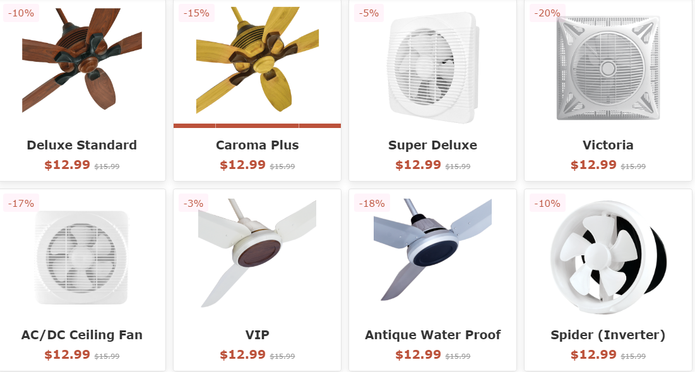

**Our Team**

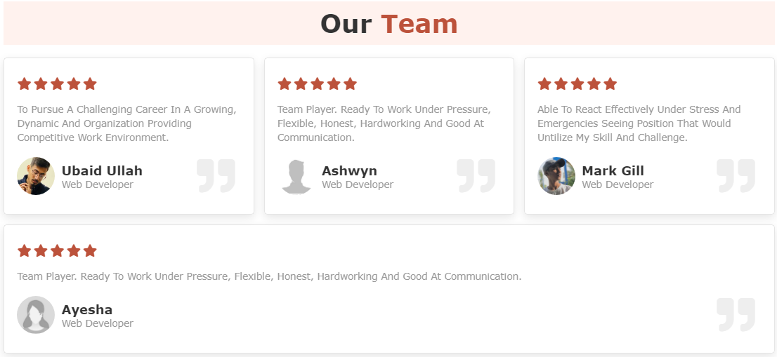

***Task Sheet***

|  |  |  |  |  |  |  |
| --- | --- | --- | --- | --- | --- | --- |
| **Website Pages** | | **ProjectTitle** | **Date Of preparation Of Activity Plan** | | | |
| No. | ***Task*** | **F**  **A**  **N**  **I**  **M**  **A**  **T**  **I**  **O**  **N** | ***Actual***  ***Start Date*** | ***Actual Days*** | ***Team-Mate***  ***Name*** | ***Status*** |
| 01. | ***Home page*** | 8  -  O  C  T  -  2  0  2  2 | 3  0  -  D  A  Y  S  - | Ashwyn |  |
| 02. | ***Gallery page*** | Ubaidullah |  |
| 03. | ***About page*** | Ayesha |  |
| 04. | ***Contact page*** | Mark Gill |  |
| 05. | ***Login/ Register page*** | Ayesha |  |
| 06. | ***Documentation*** | Ashwyn |  |